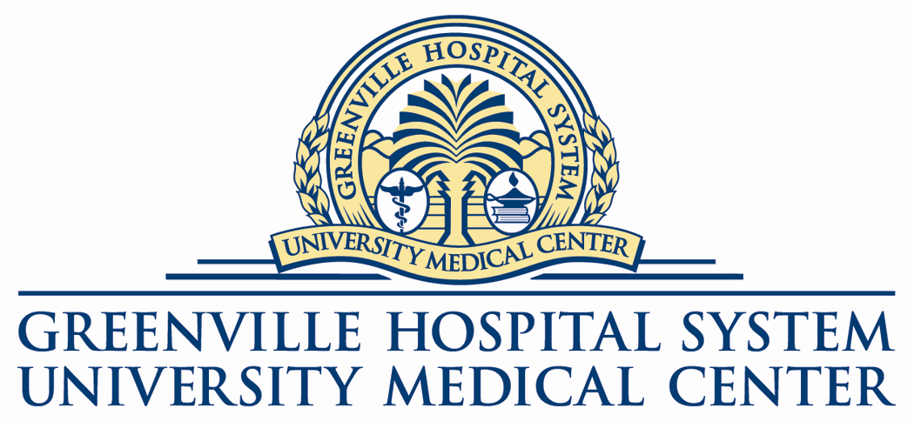

Press Release
For immediate release: Tuesday, August 16, 2005
Contacts: Mary Hassett Crissy Maynard
Vice President of Strategic Initiatives Executive Director, Marketing, Planning, and Public Relations
Bon Secours St. Francis Health System Greenville Hospital System
Phone: Office (864) 255-1250 Phone: Office (864) 455-7860

Greenville Hospital System and Bon Secours St. Francis Health System Announce Progress on Efforts to Combine Respective Hospices to Support Hospice House of Greenville

Greenville, S.C. — The community’s dream of having a hospice house facility in Greenville was made possible by the vision and perseverance of the Hospice House of Greenville Board, community generosity in the form of more than $7 million in pledges toward construction and an endowment, as well as a major donation of land from Greenville Technical College. Now, with the announcement by Greenville Hospital System and Bon Secours St. Francis Health System that Greenville Hospital System is gifting its hospice program to this endeavor, that dream is about to become a reality.

Both organizations have agreed that Bon Secours St. Francis Health System will operate the combined hospices as the hospice of record on behalf of the Hospice House of Greenville. Through the partnering efforts of the planning departments of both hospitals, a Certificate of Need application on behalf of HHG has been filed and granted. Officials expect the partnership to take effect with the opening of the new facility.

Commenting on Greenville Tech’s donation of land for the new Hospice House, Dr. Tom Barton, president of Greenville Technical College, said, “Greenville Tech has a long history of partnership with both Greenville Hospital System and Bon Secours St. Francis Health System, and we believe Greenville Tech’s donation of land on its Brashier campus in Simpsonville to the Hospice House of Greenville further strengthens this partnership. Hospice House of Greenville is an excellent example of what community organizations can achieve by coming together for the benefit of the people we serve.”

Interest in developing a hospice house facility to provide high quality, compassionate, de-institutionalized care for the dying began as a grassroots community effort a number of years ago, and led to formation of the Hospice House of Greenville Board. The not-for-profit community-based board, comprised of passionate and visionary community and business leaders, designed and developed plans for a 30-bed hospice house facility that will provide a home-like setting for inpatient care of the dying, as well as temporary or periodic residential and respite care to relieve and support families who are caring for dying loved ones at home. To date, the Hospice House of Greenville (HHG) has raised more than $6.1 million in pledges and cash-in-hand toward construction of the proposed $7.7 million facility.

Baxter Wynn, capital campaign chairman for the Hospice House of Greenville, said, “Fundraising in the community will be significantly boosted by this solid forward movement of the two hospitals. I applaud their collaborative efforts to bring this important service to our community. Their leadership will greatly enhance the success of our fundraising goals.”

Mark O’Rourke, an oncologist with CancerCenters of the Carolinas and HHG chairman, said, “This has been a complex but committed process on the part of all parties, and both hospitals have worked together admirably to support progress on our shared vision.”

The two hospitals jointly commissioned a national hospice expert to assess the financial feasibility of this project and to determine the best structural approach for long-term success of the proposed collaborative effort. Results of the consultant’s report, presented to the HHG board last week, showed that with the support of both hospitals the collaborative endeavor is indeed viable. Based on extensive interviews with community stakeholders, this collaborative effort is widely embraced as an innovative and welcome partnership between the two hospitals that supports the best interest of the community.

The two hospital boards met independently last week to discuss the most expeditious way to move this important partnership forward in order to assist HHG in meeting construction and financing deadlines. Both boards strongly endorsed the combined program.

Commenting on his board’s decision, Frank D. Pinckney, president and CEO of the Greenville Hospital System, said, “Greenville Hospital System is pleased to make this gift of its hospice program in support of the new Hospice House of Greenville. By bringing the two existing hospice programs together in this way, we are making possible a great addition to this community. The outstanding Greenville Hospital System hospice staff will make a tremendous contribution to the new entity. Their commitment and compassion combined with the Bon Secours tradition of caring for the dying will bring a high level of expertise and experience to this important community project.”

Valinda Rutledge, CEO of Bon Secours St. Francis Health System, added, “For both hospitals this has been a journey focused on expanding our collective vision in ways that are consistent with our unique yet equally caring missions. In supporting the success of Hospice House of Greenville, both organizations are concentrating their energies and resources on the community’s best interests. Greenville Hospital System’s well-respected hospice program and staff in combination with Bon Secours St. Francis Health System’s operational oversight will advance the quality of care for the dying in this community.”

Hospice House of Greenville will provide a home-like alternative to hospitalized care and will serve patients from all referring hospices in the Upstate as well as nursing home patients who qualify for hospice services.
###

